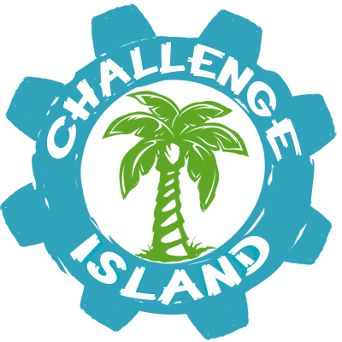

www.challenge-island.com
S.T.E.A.M. Education at W.F.C.A.
1st Grade In-School Field Trip!
Friday, February 28, 2018
WFCA is partnering with Challenge Island to provide a unique in-school STEAM (Science, Technology, Arts, and Math) field trip for all of our students this year. These fields trips are so much fun, students hardly notice the hearty math, science, arts, and technology woven into the experience. Please sign the permission slip below and submit to your homeroom teacher with $10.00. This $10.00 includes the standards based Challenge Island S.T.E.A.M. class, all materials, and a certified S.T.E.A.M. instructor.
Please contact the front office if you have any questions.
-----------------------------------------------------
Student Name:____________________________
Homeroom:_______________________________
Amount Enclosed: _________________________
- My student has permission to participate in the Challenge Island In-School field trip.
Parent Signature:____________________________________

